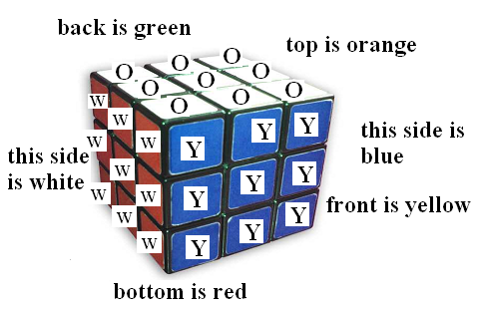The Rubik's Cube (shown to the right) is a mechanical puzzle invented in 1974 by Hungarian sculptor and professor of architecture Ernő Rubik. It is said to be the world's best-selling toy, with over 300,000,000 Rubik's Cubes being sold worldwide by 2005.
In the classic Rubik's Cube, each of the six faces is covered by nine stickers, among six solid colors (traditionally being white, yellow, orange, red, blue, and green). A pivot mechanism enables each face to turn independently, thus mixing up the colors. For the puzzle to be solved, each face must be a solid colors.
You task in this problem is implement each of the possible twelve turns with a Rubik’s cube. That is, you must track all 54 colored stickers of the cube. You must also implement the methods that return the color of any of the nine front facing colors. You may use any representation of the cube in your class, but the cube must start in the following orientation. The top of the cube is orange. The front of the cube is yellow. The color on the opposite side of the front is green. The color on the bottom is red. Facing the cube, the color to the left of yellow is white and the color to the right of yellow is blue.
Twisting a column upward would bring a red column to the front.
Twisting a column downward would bring an orange column to the front.
Twisting a row to the left (clockwise looking down at the top) brings a blue row to the front.
Twisting a row to the right (counter-clockwise looking down at the top) brings a white row to the front.
(If you are confused, keep reading, the next page should help)

In this problem the following strings will be used to represent each of the six colors:
“yellow”
“green”
“orange”
“blue”
“white”
“red”
Input / Output
You have been given the incomplete RubriksCube class. You may represent the Cube using any data structure you desire. You must implement the following 21 methods. The first nine methods return a string that represents the color of the specified front facing section. The remaining 12 methods twist and turn a column or row of the Cube.

Each of the nine following methods return the color (String) of one of the front nine facing squares.
public String getColorOfTopRowLeftColumn()
public String getColorOfTopRowMiddleColumn()
public String getColorOfTopRowRightColumn()
public String getColorOfMiddleRowLeftColumn()
public String getColorOfMiddleRowMiddleColumn()
public String getColorOfMiddleRowRightColumn()
public String getColorOfBottomRowLeftColumn()
public String getColorOfBottomRowMiddleColumn()
public String getColorOfBottomRowRightColumn()

Each of the 12 following methods twist and turn a column or row.
public void topRowToTheLeft()
public void middleRowToTheLeft()
public void bottomRowToTheLeft()
public void topRowToTheRight()
public void middleRowToTheRight()
public void bottomRowToTheRight()
public void leftColumnUp()
public void middleColumnUp()
public void rightColumnUp()
public void leftColumnDown()
public void middleColumnDown()
public void rightColumnDown()

A sample run of the RubriksCube is given below:

RubriksCube cube = new RubriksCube();
cube.getColorOfTopRowRightColumn(); // "yellow" is returned

cube.topRowToTheRight();
cube.getColorOfTopRowMiddleColumn(); // "white" is returned
cube.getColorOfMiddleRowRightColumn(); // "yellow" is returned

cube.leftColumnUp();
cube.getColorOfMiddleRowMiddleColumn(); // "yellow" is returned
cube.getColorOfBottomRowLeftColumn(); // "red" is returned

